MEK1 (E203K)
Catalog Number: CR-M26268
Gene Symbol: MAP2K1; MAPKK1; MEK1; MKK1; PRKMK1
Description: Anti-MEK1 (E203K) Mouse Monoclonal Antibody

Background: MEK1 (also known as extracellular signal-regulated kinases, ERKs) plays important role in the MAP kinase cascade, which transduces multiple extracellular signals to control cell growth, proliferation and differentiation. Activated upon growth factors stimulation, MEK1 phosphorylates MAPK3/ERK1 and MAPK1/ERK2, thus activates the MAP pathway and regulates transcription. Abnormal of the MEK1 protein, including point mutations, are implicated in diseases such as cardiofaciocutaneous syndrome (CFC) and melanoma.
Immunogen: A synthetic peptide from the internal region of MEK1 which includes the mutation of E203K, human origin.
Tested applications: ELISA,WB
Recommended dilutions:
ELISA: 1:1000-1:5000
WB: 1:500-1:1000
Concentration: 1 mg/ml
Host: Mouse
Clonality: Monoclonal
Purity: Purified from ascites
Format: Liquid
Storage buffer:
Preservative: no
Constituents: PBS (without Mg²⁺ and Ca²⁺), pH 7.4, 150 mM NaCl, 50% glycerol
Species Reactivity: Recognizes E203K mutant, but not wild-type MEK1 of vertebrates.
Storage Conditions: Store at -20°C. Avoid
freeze / thaw cycles.

Western blot:
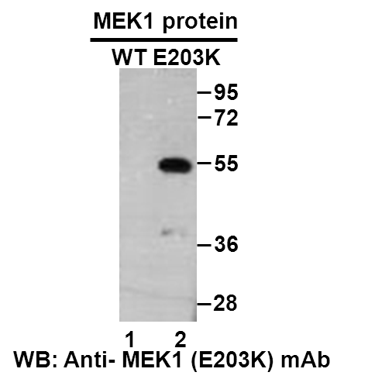
Western blot analysis of recombinant MEK1 (E203K) and wildtype proteins. Purified His-tagged MEK1 (E203K) protein (lane 2) and corresponding wildtype protein (lane 1) were blotted with anti-MEK1 (E203K) monoclonal antibody (Cat. #26268).

科博瑞（武汉）生物科技有限公司
TEL：027-87615885 15972062685
- mail：3636901710@qq.com
Web:www.coburybio.com

